**Open Call for Applied Research Projects/Prototypes**



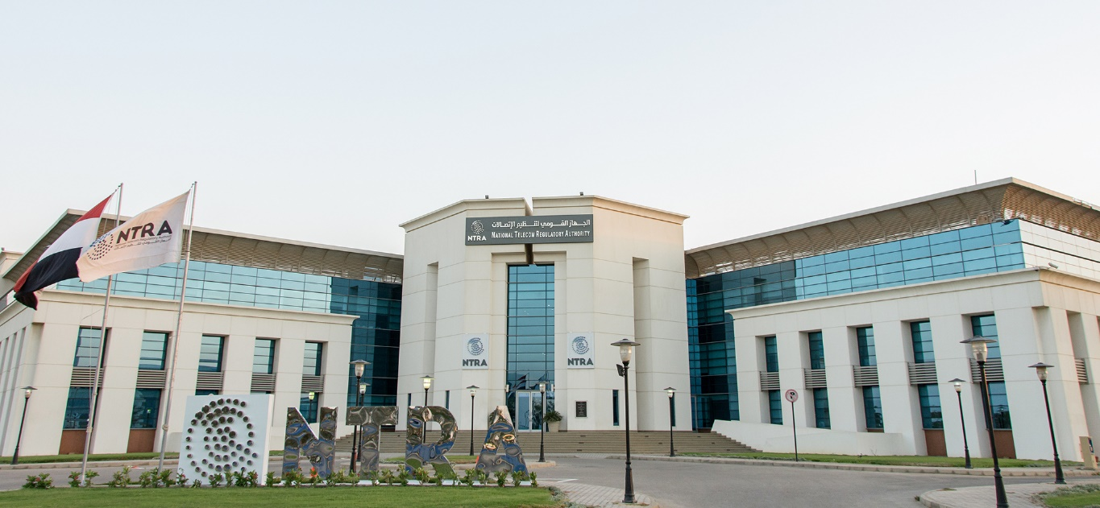

**The National Telecom Regulatory Authority (NTRA) was established by the provisions of the Telecom Regulation Law as the national authority responsible for regulating and administering the telecommunications sector. NTRA aims to enhance and deploy services in compliance with the most advanced technologies, satisfying customers' needs at the most appropriate prices, while considering transparency, open competition, universal service, and the protection of customers' rights.**

**In pursuit of this goal, NTRA keeps pace with emerging technologies and applications, aiming to bridge the gap between academic activities and technical developments, as well as political visions and real market needs. This vision is based on interaction and collaboration with a wide variety of academic and industry stakeholders to advance science and technology in key strategic domains that serve the Egyptian ICT sector at large, and contribute to the development of different solutions that can help solve key chronic challenges facing the ICT industry today.**

**The National Telecom Regulatory Authority (NTRA) Provides Technical and Financial Support for Advanced ICT Applied Research projects**

* The NTRA supports research in the telecommunications field in addition to other relevant fields. R&D is aligned with NTRA strategy designed to include academic industrial development in the telecommunication industry hence creating better services and developing solution to key chronic challenges facing ICT industry nowadays. In this target. NTRA encourage submissions anytime from researchers and practitioners who are passionate about advancing the field of telecommunications.
* The submitted proposal should aim to preparing and testing the industrial product at its final form that will meet the market needs in various sectors. **The funded projects should adopt prototypes as a final deliverable with 12 months.**

**The topics listed here, while not exclusively, will receive higher consideration and priorities:**

**Recent Trends in Telecommunications**

* **The Path Towards 5G**
* **Rural Connectivity**
* **Wireless Optical Communication**
* **Satellite Communications**

**Digital Services & Smart Communities**

* **Smart Water Managements (SWM).**
* **Smart Homes/Cities.**
* **Intelligent Transportation Systems (ITS).**
* **Smart Grids/Meters.**
* **Digital Agriculture and Smart Irrigation.**
* **E-Health/E-Education.**

**Frontier Technologies**

* **AI, IoT, Big data, Blockchain Applications in Telecommunications.**
* **Automation & Robotics and Embedded systems.**
* **Augmented Reality.**

Submit your abstract online (600 Word Max.) at[**rd.projects@tra.gov.eg**](mailto:rd.projects@tra.gov.eg)